**PRACTICAL - 8**

**AIM:** Build PERT networks, estimate activity times, and calculate project durations and completion probabilities.

**Task:**

1. Consider a software development project with the following activities:

A: Define Requirements,B: Design Database,C: Develop Frontend,D: Implement Backend,E: Perform Testing,F: Deployment

The dependencies are as follows:

A depends on nothing,B depends on A,C depends on A,D depends on B and C,E depends on D,F depends on E,

Construct a PERT network diagram for this project.

Consider the following PERT estimates for a software development project:

Activity A: Optimistic Time = 2 weeks, Most Likely Time = 4 weeks, Pessimistic Time = 6 days

Activity B: Optimistic Time = 3 weeks, Most Likely Time = 5 weeks, Pessimistic Time = 7 days

Activity C: Optimistic Time = 3 weeks, Most Likely Time = 6 weeks, Pessimistic Time = 9 days

Activity D: Optimistic Time = 4 weeks, Most Likely Time = 7 weeks, Pessimistic Time = 10 days

Activity E: Optimistic Time = 2 weeks, Most Likely Time = 4 weeks, Pessimistic Time = 6 days

Activity F: Optimistic Time = 1 week, Most Likely Time = 2 weeks, Pessimistic Time = 3 days

Determine estimate activity times, and calculate project durations probabilities of completing the project within 14 weeks.

**Solution:**

**Team Details:**

| **Sr. No.** | **Enrolment no** | **Name** |
| --- | --- | --- |
| **Team Leader** | **Yash Patel** | **202203103510228** |
| **Team Member 1** | **Gati Shah** | **202203103510261** |
| **Team Member 2** | **Angat Shah** | **202203103510097** |
| **Team Member 3** | **Fenil Shilodre** | **202203103510041** |
| **Team Member 4** | **Sarth Chaudhari** | **202303103510106** |

**Project Title : Airbnb System**

## PERT Time Estimation

| **Activity** | **Description** | **Optimistic (O)** | **Most Likely (M)** | **Pessimistic (P)** |
| --- | --- | --- | --- | --- |
| A | Requirement Analysis | 4 | 5 | 6 |
| B | UI/UX Design | 6 | 8 | 10 |
| C | Backend Development | 8 | 10 | 12 |
| D | Frontend Development | 10 | 12 | 14 |
| E | Payment Gateway Integration | 5 | 6 | 7 |
| F | Testing | 6 | 8 | 10 |
| G | Deployment | 3 | 4 | 5 |

## Calculation For Expected Time (TE) For Each Activity

* PERT Formula for Expected Time :

$TE =\frac{ O + 4M + P}{6}$

| **Activity** | **TE Calculation** | **Expected Time (TE)** |
| --- | --- | --- |
| A | $\frac{ 4 + 4(5) + 6}{6} = \frac{ 30}{6}$ | **5 Weeks** |
| B | $\frac{ 6 + 4(8) + 10}{6} = \frac{ 48}{6}$ | **8 Weeks** |
| C | $\frac{ 8 + 4(10) + 12}{6} = \frac{ 60}{6}$ | **10 Weeks** |
| D | $\frac{ 10 + 4(12) + 14}{6} = \frac{ 72}{6}$ | **12 Weeks** |
| E | $\frac{ 5 + 4(6) + 7}{6} = \frac{ 36}{6}$ | **6 Weeks** |
| F | $\frac{ 6 + 4(8) + 10}{6} = \frac{ 48}{6}$ | **8 Weeks** |
| G | $\frac{ 3 + 4(4) + 5}{6} = \frac{ 24}{6}$ | **4 Weeks** |

1. **Critical Path Analysis (PERT)**

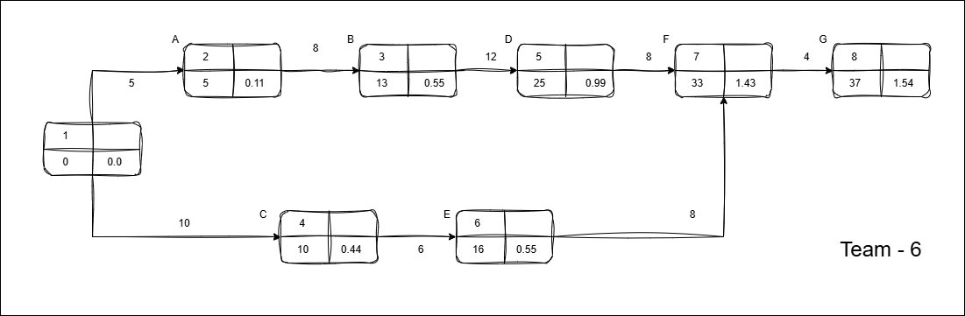**PERT Network**

* From CPM, the **critical path** **:** **A → B → D → F → G**
* Total duration = 5 + 8 + 12 + 8 + 4 = **37 weeks**

*(No change from CPM since, TE = original durations.)*

1. **Probability of Completing Project in 35 Weeks**

* **Step 1:** Variance (σ²) for Critical Path Activities Calculation

The Formula for Variance :

$σ^{2}={{\left(\frac{P - O}{6}\right)}^{2}}^{}$

| **Activity** | **P - O** | **σ²** | **σ** |
| --- | --- | --- | --- |
| A | 6 - 4 = 2 | ${\left(\frac{2}{6}\right)}^{2}$ ≈ **0.111** | 0.33 |
| B | 10 - 6 = 4 | ≈ **0.444** | 0.67 |
| D | 14 - 10 = 4 | ≈ **0.444** | 0.67 |
| F | 10 - 6 = 4 | ≈ **0.444** | 0.67 |
| G | 5 - 3 = 2 | ≈ **0.111** | 0.33 |

**Total Variance (Σσ²)** = 0.111 + 0.444 + 0.444 + 0.444 + 0.111 = **1.554**

* **Step 2:** Calculation for Standard Deviation (σ)

*σ* = ≈ 1.25 Weeks

* **Step 3:** Computing Z-Score for 35 Weeks

$z = \frac{T - TE}{σ}$ = $\frac{35-37}{1.25}$ = - 1.6

* **Step 4:** Find Probability from Z-Table

From the standard normal distribution table,

| **Z** | 0.00 |
| --- | --- |
| **-1.6** | .05480 |

A z-score of **-1.6** corresponds to a **~ 5.5% probability**.

*This makes sense because 35 weeks is* ***2 weeks shorter*** *than the expected 37-week duration and the variance is relatively low.*

1. **Probability of Completing Project in 39 Weeks**

* **Step 1:** Variance (σ²) for Critical Path Activities Calculation

The Formula for Variance :

$σ^{2}={{\left(\frac{P - O}{6}\right)}^{2}}^{}$

| **Activity** | **P - O** | **σ²** | **σ** |
| --- | --- | --- | --- |
| A | 6 - 4 = 2 | ${\left(\frac{2}{6}\right)}^{2}$ ≈ **0.111** | 0.33 |
| B | 10 - 6 = 4 | ≈ **0.444** | 0.67 |
| D | 14 - 10 = 4 | ≈ **0.444** | 0.67 |
| F | 10 - 6 = 4 | ≈ **0.444** | 0.67 |
| G | 5 - 3 = 2 | ≈ **0.111** | 0.33 |

**Total Variance (Σσ²)** = 0.111 + 0.444 + 0.444 + 0.444 + 0.111 = **1.554**

* **Step 2:** Calculation for Standard Deviation (σ)

*σ* = ≈ 1.25 Weeks

* **Step 3:** Computing Z-Score for 35 Weeks

$z = \frac{T - TE}{σ}$ = $\frac{39-37}{1.25}$ = 1.6

* **Step 4:** Find Probability from Z-Table

From the standard normal distribution table,

| **Z** | 0.00 |
| --- | --- |
| **1.6** | .94520 |

A z-score of **1.6** corresponds to a **~ 94.5% probability**.

*This makes sense because 39 weeks is* ***2 weeks longer*** *than the expected 37-week duration and the variance is relatively high.*

**Project Title : Farfetch E-commerce System**

## PERT Time Estimation

| **Activity** | **Description** | **Optimistic (O)** | **Most Likely (M)** | **Pessimistic (P)** |
| --- | --- | --- | --- | --- |
| A | Requirement Analysis | 5 | 6 | 7 |
| B | Product Catalog Design | 6 | 7 | 8 |
| C | Recommendation Engine Dev | 12 | 14 | 16 |
| D | Payment Gateway Integration | 8 | 10 | 12 |
| E | UI/UX Design | 7 | 8 | 9 |
| F | Frontend & Backend Development | 16 | 18 | 20 |
| G | Testing | 10 | 12 | 14 |
| H | Deployment | 4 | 5 | 6 |

## Calculation For Expected Time (TE) For Each Activity

* PERT Formula for Expected Time :

$TE =\frac{ O + 4M + P}{6}$

| **Activity** | **TE Calculation** | **Expected Time (TE)** |
| --- | --- | --- |
| A | $\frac{ 5 + 4(6) + 7}{6} = \frac{ 36}{6}$ | **6 Weeks** |
| B | $\frac{ 6 + 4(7) + 8}{6} = \frac{ 42}{6}$ | **7 Weeks** |
| C | $\frac{ 12 + 4(14) + 16}{6} = \frac{ 84}{6}$ | **14 Weeks** |
| D | $\frac{ 8 + 4(10) + 12}{6} = \frac{ 60}{6}$ | **10 Weeks** |
| E | $\frac{ 7 + 4(8) + 9}{6} = \frac{ 48}{6}$ | **8 Weeks** |
| F | $\frac{ 16 + 4(18) + 20}{6} = \frac{ 108}{6}$ | **18 Weeks** |
| G | $\frac{ 10 + 4(12) + 14}{6} = \frac{ 72}{6}$ | **12 Weeks** |
| H | $\frac{ 4 + 4(5) + 6}{6} = \frac{ 30}{6}$ | **5 Weeks** |

1. **Critical Path Analysis (PERT)**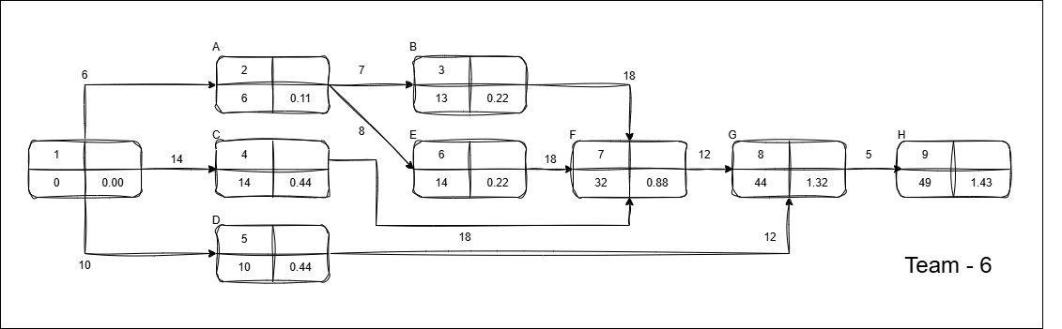

**PERT Network**

* From CPM, the **critical path** is: **C→ F → G → H**
* Total duration = 6 + 14 + 8 + 18 + 12 + 5 = **49 weeks**.

*(Non-critical activities like B and D have slack and won’t delay the project.)*

1. **Probability of Completing Project in 48 Weeks**

* **Step 1:** Variance (σ²) for Critical Path Activities Calculation

The Formula for Variance :

$σ^{2}={{\left(\frac{P - O}{6}\right)}^{2}}^{}$

| **Activity** | **P - O** | **σ²** | **σ** |
| --- | --- | --- | --- |
| C | 16 - 12 = 4 | ≈ **0.444** | 0.67 |
| F | 20 - 16 = 4 | ≈ **0.444** | 0.67 |
| G | 14 - 10 = 4 | ≈ **0.444** | 0.67 |
| H | 6 - 4 = 2 | ≈ **0.111** | 0.33 |

**Total Variance (Σσ²)** = 0.444 + 0.444 + 0.444 + 0.111 = **1.443**

* **Step 2:** Calculation for Standard Deviation (σ)

*σ* = ≈ 1.20 Weeks

* **Step 3:** Computing Z-Score for 35 Weeks

$z = \frac{T - TE}{σ}$ = $\frac{48-49}{1.20}$ = - 0.83

* **Step 4:** Find Probability from Z-Table

From the standard normal distribution table,

| **Z** | 0.03 |
| --- | --- |
| **- 0.8** | .20327 |

A z-score of - **0.83** corresponds to a **~ 20.3 % probability**.

*This makes sense because 48 weeks is* ***1 week shorter*** *than the expected 49-week duration and the variance is relatively low.*

1. **Probability of Completing Project in 50 Weeks**

* **Step 1:** Variance (σ²) for Critical Path Activities Calculation

The Formula for Variance :

$σ^{2}={{\left(\frac{P - O}{6}\right)}^{2}}^{}$

| **Activity** | **P - O** | **σ²** | **σ** |
| --- | --- | --- | --- |
| C | 16 - 12 = 4 | ≈ **0.444** | 0.67 |
| F | 20 - 16 = 4 | ≈ **0.444** | 0.67 |
| G | 14 - 10 = 4 | ≈ **0.444** | 0.67 |
| H | 6 - 4 = 2 | ≈ **0.111** | 0.33 |

**Total Variance (Σσ²)** = 0.444 + 0.444 + 0.444 + 0.111 = **1.443**

* **Step 2:** Calculation for Standard Deviation (σ)

*σ* = ≈ 1.20 Weeks

* **Step 3:** Computing Z-Score for 35 Weeks

$z = \frac{T - TE}{σ}$ = $\frac{50-49}{1.20}$ = 0.83

* **Step 4:** Find Probability from Z-Table

From the standard normal distribution table,

| **Z** | 0.03 |
| --- | --- |
| **0.8** | 0.79673 |

A z-score of **0.83** corresponds to a **~ 79.7% probability**.

*This makes sense because 50 weeks is* ***1 week longer*** *than the expected 49-week duration and the variance is relatively high.*